Ruby on Rails
Ruby on Rails is a Web application framework for Ruby. It was first released to the public in July 2004.
Within months, it was a widely used development environment. Many multinational corporations are using it to create Web applications.
It is the standard Web-development framework for Ruby.

Model/View/Controller
All Rails applications are implemented using the Model/View/Controller (MVC) architecture.
Models are objects that represent the components of an application that perform information processing in the problem domain.

Models should represent “real world” entities:
- physical entities like a valve in a control system, or
- conceptual entities like a department in an office, or a contract between two businesses.
Views are objects that display some aspect of the model. They are the output mechanism for the models.

You could have a view that represents:
- the position of the valve or the temperature of a chemical vat (graphical)
- cells in a spreadsheet (tabular)
- the terms and conditions of a contract (textual)
- product installation instructions (video or audio)
Controllers are objects that control how user actions are interpreted. They are the input mechanism for the views and models.

For example, the interpretation of a double-click on a temperature gauge would be handled by the controller notifying the model in a way it agrees to respond to.

MVCs come in a triad, with communication between the components occurring as follows:
Whenever the state of a model changes, the view needs to display itself differently.

For instance, consider a View that represents a car’s engine temperature.

If the engine temperature goes up (say, because a fan belt breaks) the gauge showing the temperature will need to redisplay its new value in response to that change.
In Rails, when a project is created, it is given folders for model, view, and controller classes.
A Rails application accepts an incoming request from a Web page, then gives it to a router. The router parses the URL and eventually directs the request to a particular controller.
For example, the URL might be something like
http://expertiza.ncsu.edu/users/show/108.

This means to show the various fields in the entry for User 108 (name, e-mail address, role). In this case,
- the controller is users,
- the action is show, and
- the ID of the user is 108.
Or, we might have something like http://www.etailer.com/store/add_to_cart/353.
What do you think this would represent?

The Rails Cookbook Application
After we start the server, we see this series of messages:
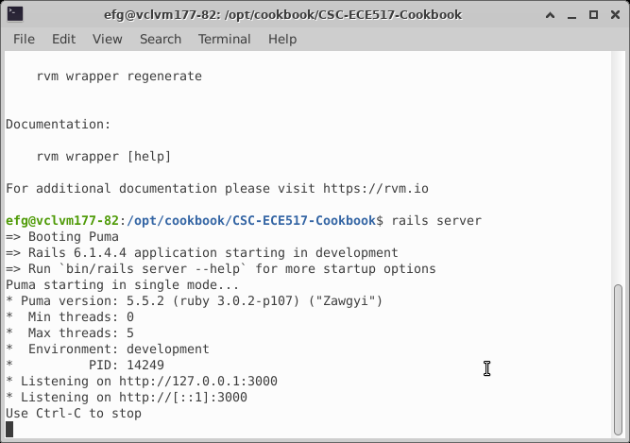
When we visit the application in our browser, we see this initial screen:
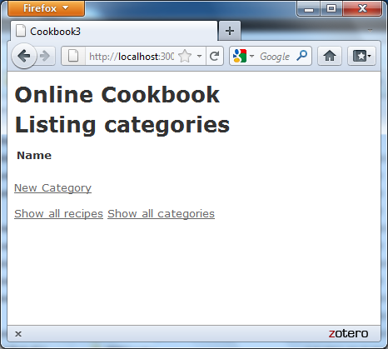
Let’s create a category:
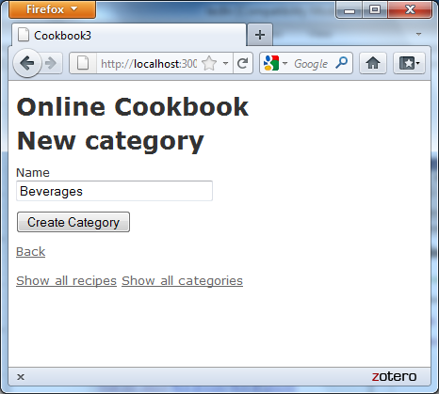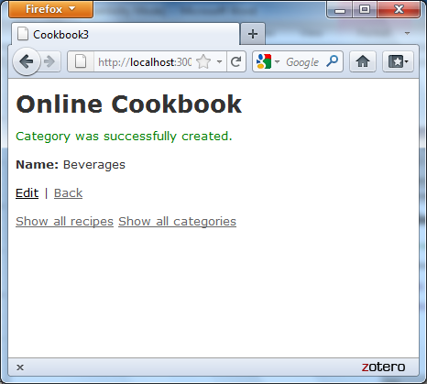

And a couple of beverages …
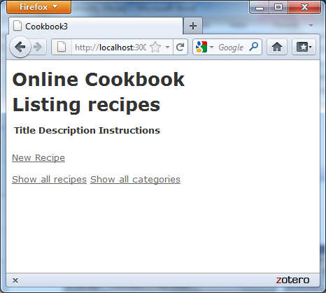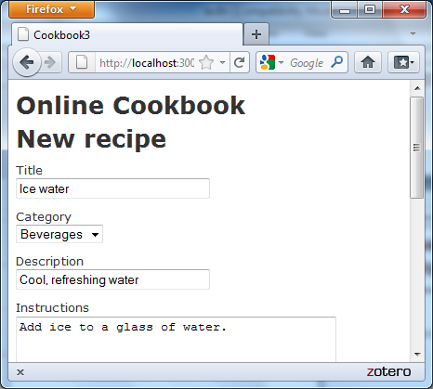

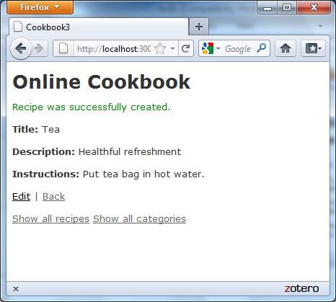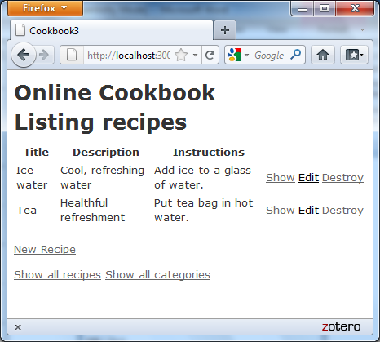
Now let’s go and look at what’s in the database:
- Go to View → Tool Windows → Database.
- Make sure that Development: Cookbook is added as a data source (see the RubyMine setup instructions for how to do this).
- Double-clicking on a table will show the records in that table.
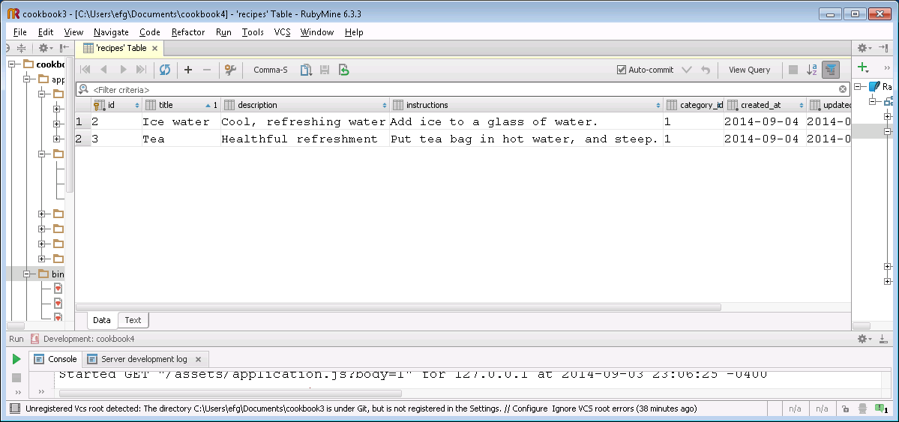
Notice the created_at and updated_at fields. These are automatically updated with the timestamp of the time that a row was created or updated.
Also notice the category_id. What do you think this is

The controllers
Let’s take a look at the code for categories_controller.rb.
class CategoriesController < ApplicationController
# GET /categories
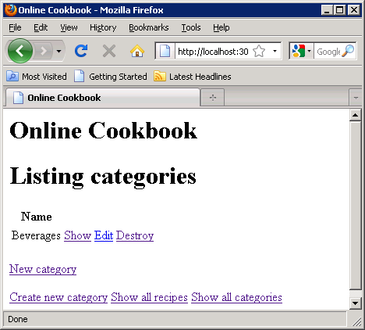
# GET /categories.json
Note that it consists of set of actions, with each method implementing one of the actions.
def index
@categories = Category.all
respond_to do |format|
format.html # index.html.erb
format.json { render json: @categories }
end
end
The statement inside the method does a database lookup of all categories, and assigns the resulting array to the @categories instance variable.
Without web-service support, that would be the whole method. The code that follows determines whether to respond with HTML (as when we are interacting with a user) or JSON (if we are returning an object).
What that says is, "if the client wants HTML, just send back the categories in HTML, but if the client wants JSON, return the list of categories in JSON format.” The response format is determined by HTTP Accept header sent by the client.
Immediately after executing a method, e.g., index, the controller will render a template of the same name. This template is in the corresponding directory in the views folder. In this case, the template is views/categories/index.html.erb. In a few minutes, we will talk about .erb files.
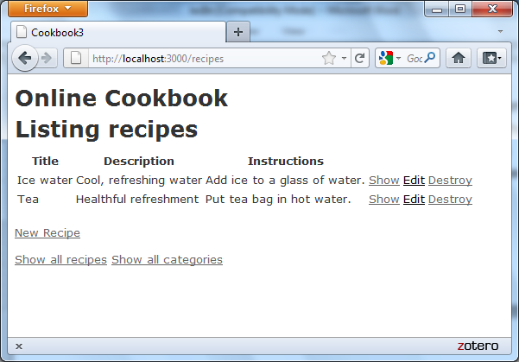
There is very little difference between the index method and the show method.
# GET /categories/1
# GET /categories/1.json
def show
@category = Category.find(params[:id])

respond_to do |format|
format.html # show.html.erb
format.json { render json: @category }
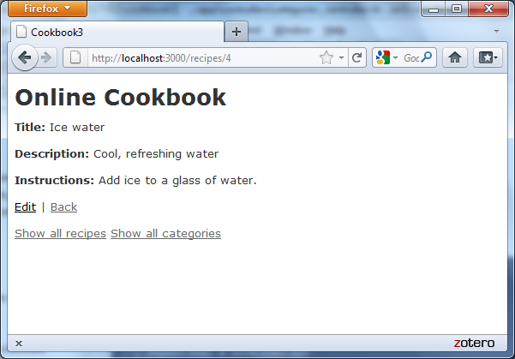
end
end
The show method looks for a category with a particular key. Its output is very basic (above). The formatting is different (the text “Listing categories” doesn’t appear, etc.) because the corresponding views are different (as we will see).
Look again at the difference between the assignment statements involving categories.
- index has @categories = Category.all
- show has @category = Category.find(params[:id])
Both of these methods do retrievals from the categories table in the db.
- The all method retrieves all records from the categories table and assigns the collection to a variable called @categories.
- The find(...) method retrieves a particular record, the record with the specified id.
This is the first use we have seen of Active Record.
Now, as an exercise, see if you can arrange this set of statements to form the index method of recipes_controller.rb.

Active Record
Our Ruby on Rails programs deal with objects, but they are mapped into relational databases.
There’s a mismatch here—how are the database tables translated into objects, and how are objects created in the program saved to the db?
Ruby on Rails’ solution is Active Record. In Active Record,
- Database tables correspond to Rails (model) classes.
- Database records (rows) correspond to Rails objects.
We can perform operations on tables by invoking class methods, as is done in both the RecipesController and the CategoriesController:
@recipes = Recipe.all
@categories = Category.all
Let’s take a closer look at the find in the show method:
Category.find(params[:id])
This illustrates two common features of Active Record calls.
- params is an object (a hash) that holds all of the parameters passed in a browser request.
- params[:id] holds the id, or primary key, of the object.
When you click a link for a specific category, the id of that category is passed in the params object, so that show can display that category.
Now, if you are running the application on your computer, you can test what happens if you delete a category that contains a recipe.

Method pairs
Next we have the new and create methods. Sounds like they might do the same thing …
What’s the difference between the two? Well, which one is called first?
The method prepares the form for display; the method processes the data that was entered and attempts to save it to the db.
# GET /categories/new
def new
@category = Category.new
respond_to do |format|
format.html # new.html.erb
format.json { render json: @category }
end

# POST /categories
# POST /categories.json
def create
@category = Category.new(category_params)

respond_to do |format|
if @category.save
format.html { redirect_to @category, notice: 'Category was successfully created.' }
format.json { render json: @category, status: :created, :location: @category }
else
format.html { render action: "new" }
format.json { render json: @category.errors, :status: :unprocessable_entity }
end
end
end
There is a similar distinction between edit and update. Edit retrieves a table entry and displays it in a window. When the changes are submitted, update is invoked.
new
create
edit
update
# GET /categories/1/edit
def edit
@category = Category.find(params[:id])
end

# PUT /categories/1
# PUT /categories/1.xml
def update
respond_to do |format|
if @category.update_attributes(category_params)
format.html { redirect_to @category, notice: 'Category was successfully updated.' }
format.json { head :no_content }
else
format.html { render action: 'edit' }
format.xml { render json: @category.errors, status: :unprocessable_entity }
end
end
end

# DELETE /categories/1
# DELETE /categories/1.xml
def destroy
@category.destroy

respond_to do |format|
format.html { redirect_to categories_url }
format.xml { head :no_content }
end
end
The categories_controller is extremely similar to the recipes_controller. Let’s take a look …
These controllers were generated by the Rails scaffold mechanism. We can use the scaffold to create a recipes table, with title, description, and instructions fields.
We can then proceed to exercise the application as we did before. But now we can change its functionality too.
Let’s make a trivial change: Change “Show all recipes” and “Show all categories” to “List all recipes and “List all categories”.
Where shall we make this change?
Well, if we click on “Show all categories”, we get this screen.
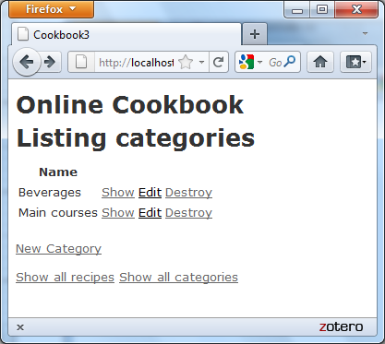
What do you notice about the bottom line?
And if we click on “Create new recipe”, we get this screen:
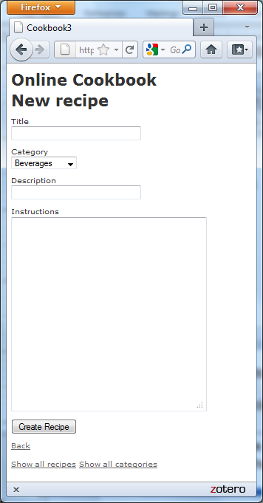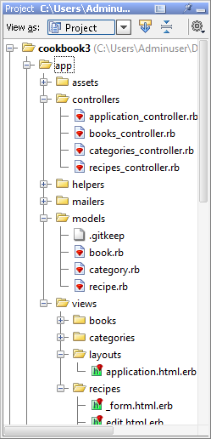
Again, the bottom line is the same. Let’s take a look at the directory listing. Which file do you think contains that code?

This is an .html.erb file, the first time we’ve seen this type. What do you think it stands for?
Let’s look at the code in this file.
<!DOCTYPE html>
<html>
<head>
<title>Online Cookbook</title>
<%= stylesheet_link_tag "application", :media => "all" %>
<%= javascript_include_tag "application" %>
<%= csrf_meta_tags %>
</head>
<body>
<h1>Online Cookbook</h1>

<%= yield %>
<br><br>

<%= link_to "Show all recipes", recipes_url %> <%= link_to "Show all categories", categories_url %>

</body>
</html>
This raises several questions.
- What gets invoked when we click on the “Show all recipes” link?
- What is the <%= yield %> for?
- What do “recipes_url”, “categories_url”, etc., mean?
Some actions, like deleting an object, are dangerous. Our app should—and does—guard against performing them by accident. What code could we add to do the same when updating a recipe?
Now, here are some review questions.
- What URL do we type in to find the homepage of our cookbook application?
- When we click on “Show all categories”, what URL will be taken to?

Routes
Routes are a way to take incoming requests from the web and redirect them to specific controllers and actions (actions == methods).
In the routes.rb file, you just declare
resources :categories
and this generates routes for each of the methods for the categories_controller.
In the table below, the path is the tail of the URL that is visited.
When that path is visited, a particular controller is invoked. The action is the method of the controller that will be called.
HTTP Verb | Path | Controller#Action | Used for
GET | /categories | categories#index | display a list of all categories
GET | /categories/new | categories#new | return an HTML form for creating a new category
POST | /categories | categories#create | create a new category
GET | /categories/:id | categories#show | display a specific category
GET | /categories/:id/edit | categories#edit | return an HTML form for editing a category
PATCH/PUT | /categories/:id | categories#update | update a specific category
DELETE | /categories/:id | categories#destroy | delete a specific category

Some paths specify an id, which is the object (or database record) that is being acted upon.
Also, creating routes creates “helpers” …
Variable | Value | Example
categories_path | /categories
new_category_path | /categories/new
edit_category_path(:id) | /categories/:id/edit | edit_category_path(10) → /categories/10/edit
category_path(:id) | /categories/:id | category_path(10) → /categories/10
For each _path variable, there is a corresponding _url variable that contains the whole path, e.g., http://localhost:3000/categories/new
Test your knowledge of routes with this exercise.

The models
There are only two files in the model, one each for the tables in the application.
Let’s take a look at them.

category.rb
class Category < ActiveRecord::Base
has_many :recipes
validates :name, :presence => true
end

recipe.rb
class Recipe < ActiveRecord::Base
belongs_to :category
validates :title, :presence => true
validates :description, :presence => true
validates :instructions, :presence => true
validates :category, :presence => true
end

Many validations can be applied to fields of a model object. This Rails Guide describes them. Use it to answer these questions about validations that could be added to our Cookbook app.
The validates of Rails 3 can be replaced with a strong-parameter mechanism, starting with Rails 4.
This prevents mass assignment, which is a security hole.

Active Record associations
A relationship between two objects may be
- one-to-one (e.g., a course has a syllabus and a syllabus belongs to one course).
  - class Syllabus < ActiveRecord::Base
belongs_to :course
# …
end
  - class Course < ActiveRecord::Base
has_one :syllabus
# …
end
- one-to-many (e.g., a course has many assignments)
  - class Assignment < ActiveRecord::Base
belongs_to :course
# …
end
  - class Course < ActiveRecord::Base
has_many :assignments
# …
end
- many-to-many (e.g., a course has many students; students have many courses)
  - class Student < ActiveRecord::Base
has_and_belongs_to_many :courses
# …
end
  - class Course < ActiveRecord::Base
has_and_belongs_to_many :students
# …
end
Rails calls these relationships associations.
You should be able to answer the following questions about these files.
- What kind of relationship is there between recipes and categories?
- Where is this relationship represented?
Earlier, we saw that deleting a category before deleting its recipes caused an error. Now, by reading Section 1 of Active Record Associations, you should be able to determine how to fix this problem.
Now, you can probably see how models, views, and controllers fit together.

The views
Now, let’s take a look at the View code for the categories. We’ll look at it line by line, which may obscure the flow, but if you have trouble, just look in your Cookbook folder for the uncommented code.

edit.html.erb
<h1>Editing category</h1>

<%= render 'form' %>

<%= link_to 'Show', @category %> |
<%= link_to 'Back', categories_path %>

The form refers to a partial named _form.html.erb.

_form.html.erb
<%= form_for(@category) do |f| %>
<% if @category.errors.any? %>
<div id="error_explanation">
<h2><%= pluralize(@category.errors.count, "error") %> prohibited this category from being saved:</h2>

<ul>
<% @category.errors.full_messages.each do |msg| %>
<li><%= msg %></li>
<% end %>
</ul>
</div>
<% end %>

<div class="field">
<%= f.label :name %><br>
<%= f.text_field :name %>
</div>
<div class="actions">
<%= f.submit %>
</div>
<% end %>
Compare this with _form.html.erb for recipes:
<%= form_for(@recipe) do |f| %>
<% if @recipe.errors.any? %>
<div id="error_explanation">
<h2><%= pluralize(@recipe.errors.count, "error") %> prohibited this recipe from being saved:</h2>

<ul>
<% @recipe.errors.full_messages.each do |msg| %>
<li><%= msg %></li>
<% end %>
</ul>
</div>
<% end %>

<div class="field">
<%= f.label :title %><br>
<%= f.text_field :title %>
</div>
<div class="field">
<%= f.label :description %><br>
<%= f.text_field :description %>
</div>
<div class="field">
<%= f.label :category %><br />
<%= select("recipe", "category_id", Category.all.collect{ |c| [ c.name, c.id] }) %>
</div>
<div class="field">
<%= f.label :instructions %><br>
<%= f.text_area :instructions %>
</div>
<div class="actions">
<%= f.submit %>
</div>
<% end %>
Explain the differences.

show.html.erb
This file has very basic functionality.

<p id="notice"><%= notice %></p>

<p>
<b>Name:</b>
<%= @category.name %>
</p>

<%= link_to 'Edit', edit_category_path(@category) %> |
<%= link_to 'Back', categories_path %>
Compare with show.html.erb for recipes.
<p id="notice"><%= notice %></p>

<p>
<b>Title:</b>
<%= @recipe.title %>
</p>

<p>
<b>Description:</b>
<%= @recipe.description %>
</p>

<p>
<b>Instructions:</b>
<%= @recipe.instructions %>
</p>

<%= link_to 'Edit', edit_recipe_path(@recipe) %> |
<%= link_to 'Back', recipes_path %>

new.html.erb
The only remaining view is new.html.erb. It doesn’t illustrate much that we haven’t seen before, so I’ll ask you the questions (below).
<h1>New category</h1>

<%= render 'form' %>

<%= link_to 'Back', categories_path %>

- Which controller is invoked when the form is submitted? Where is the code for this controller?
- What says to print out a blank for the name of the category?

