Question 1. (2/3 point per blank) Consider a system that has 3 processors with private writeback caches using the SSCI protocol, where each line holds a single integer value (e.g., block size of 4 bytes).

“– “ indicates that we don’t know what’s in a particular cache line. Initially, the cache for each processor is empty.
Memory contents
Variable | Value
X | 1
Y | 3

Fill in the blank spaces, showing the cache states and memory value for the variable referenced on that line (Y in the first 3 lines, X in the next three, Y in the last three).
Oper- ation | P1 |  |  |  | P2 |  |  |  | P3 |  |  |  | Memory
Oper- ation | Value | State | Prev | Next | Value | State | Prev | Next | Value | State | Prev | Next | Value | State | Head
P2: read Y | – | – | – | – | 3 | E |  |  | – | – | – | – | 3
P2: Y = 4 | – | – | – | – | 4 | M |  |  | – | – | – | – | 3
P1: read Y | 4 | S |  |  |  | S |  |  | -- | -- | -- | -- | 4 | S
P3: X = 5 | -- | -- | -- | -- | – | – | – | – | 5 | M | 0 | 0 |  |  | 3
P1: read X |  |  | 0 | 3 | – | – | – | – |  |  | 1 | 0
P3: X = 6 | 5 | I | 0 | 3 | – | – | – | – | 6 | M | 0 | 0 |  | EM | 3
P1: Y = 7 | 7 |  | 0 | 0 | 4 | I | 3 | 0 | -- | -- | -- | -- | 4 | EM
P3: Y = 8 | 7 | I | 0 | 0 | 4 | I | 3 | 0 |  |  | 0 | 0 |  | EM | 3
P3: Y = 9 | 7 | I | 0 | 0 | 4 | I | 3 | 0 | 9 | M | 0 | 0 |  | EM | 3

Question 2. (a) (10 points; 2 points per line) Consider a 3-processor DSM with private write-back caches. It uses a full bit-vector implementation (FBV) of the directory-based MESI protocol. For simplicity’s sake, assume that a cache contains only 1 word, and we are only concerned with a single line in the cache.
The table below uses one line to represent each operation. The table columns show
- for each cache, the state of its cache line, value in the cache line and the action induced by the protocol. A dash (“–“) indicates that the line is empty.
- for the memory, the value in the corresponding memory cell, the directory state after the operation, and the action induced by the protocol.
Initially, the caches are empty and the corresponding memory cell contains 1.
Fill in the blanks in the table. Note that the number in the bracket refers to the order that messages are sent. For example, when processor 0 reads the location, it sends a message to the home node [1]. The home node sends back a ReplyD [2].
 | Processor 0 |  |  | Processor 1 |  |  |  | Processor 2 |  |  |  | Main Memory
Op | State | Data | Action | State | Data | Action | State |  | Data | Action | Data |  | State,FBV | Action
R0 | E | 1 | [1]Read→H | – | – | – | – |  | – | – | 1 |  | EM,100 | [2]ReplyD→P0
R1 | S | 1 | [3]Flush→H  [3]Flush→P1 | S | 1 | [1]Read→H | – |  | – | – | 1 |  | S,110 | [2]Int→P0
R2
W1=4
W2=3
R2
W0=7
(b) (5 points) There are several Read and ReadX processor transactions in the simplified directory-based MESI coherence protocol finite-state diagram below. There is no processor “Write” transactions to the main memory. Why not?
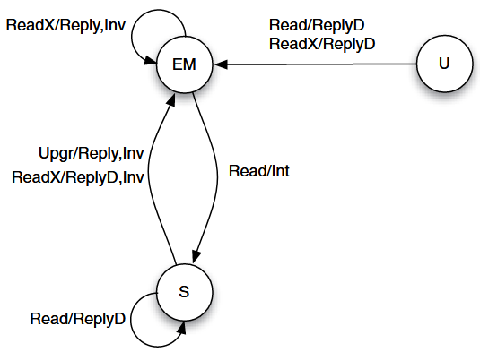

Question 3. In this sequence, assume that initially, flag0 = flag1 = 0, and A = B = u = v = w = 2.
Note that not all vairables are initialized to 0!
P0:  S0: A = 1;  S1: B = 5;  S2: u = B;  S3: flag0 = 1; | P1:  S4: while (!flag0){};  S5: v = B – A;  S6: w = A;  S7: flag1 = 1; | P2:  S8: while (!flag1){};  S9: x = u × w + v;
(a) (6 points) What values could be produced for x under processor consistency? List all such values.
(b) (6 points) Which writes by different processors are causally related in this sequence? Simply list pairs of statements (e.g., {S0, S4}) where the write in the second statement is causally related to the first. Just list the pairs that are directly related, don’t write out the transitive closure. And don’t write down any pairs that are executed by the same processor.
(c) (4 points) What values could be produced for x under causal consistency? Explain how you have determined this.
(d) (4 points) If weak ordering is in use, what is the minimum set of variables that should be treated as synchronization variables in order to assure the same results as under sequential consistency? Explain why fewer synchronization variables will not suffice.
Question 4. Suppose two processors execute the following code:

P₁ | P₂
1a A = 1  1b d = A  1c print e, f | 2a B = 1  2b e = B  2c f = A  2d print d

(a) (8 points) Which of the eight combinations of values for (d, e, f) can be printed under sequential consistency?

(b) (4 points) Choose two of the combinations that are impossible and explain why they are not possible under sequential consistency.

(c) (2 points) Under processor consistency, which—if any—additional combinations of values can be printed? How?

(e) (2 points) Under weak ordering, which—if any—additional combinations of values can be printed? How?

(f) (3 points) Pick one of these models (PC or WO) that can print combinations not possible with SC. Tell where you would insert fence (SYNC) operations to make it conform to SC.

Question 5. Consider this code run on two processors.
P1 | P2
lock(L)  A = A * P1_value  B = B + P1_value  C = C / P1_value  unlock(L)  next_P1_value = input1 * 2  P1_value = next_P1 value | lock(L)  A = A * P2_value  B = B + P2_value  C = C / P2_value  unlock(L)  next_P2_value = input1 * 2  P2_value = next_P2 value
(a) (3 points) In the code above, what performance advantage would release consistency provide over weak ordering, if any? Assume A, B, and C are shared variables. All others are not.

(b) (3 points) Two systems are running the code above. System A has very high bus bandwidth utilization. System B has low bus bandwidth utilization. Which memory consistency model would be better for each system, Release Consistency or Lazy Release Consistency? Explain your choice.

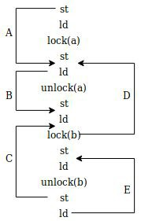
(c) (3 points each, except 2 points for E) In the instruction stream at the right, ld and st represent load and store memory accesses respectively. In a relaxed consistency model, instructions can be observed to occur in a different order than they are actually executed.
Arrows A, B, C, D, and E show a reordering of when memory accesses are seen. For example, arrow A means that the first st operation is observed to occur after the st operation following lock(a).

